­COSC407: Data Communication and Networks

­LAB 4: Variable Length Subnet Mask (VLSM)

1.1 OBJECTIVES: At the end of the lab session the students should be able to:

1. Differentiate between FLSM and VLSM
2. Subnet an IP Address using Variable Length Subnet Mask (VLSM)
3. Know the Advantages of VLSM over FLSM
4. State remaining unassigned or free addresses remaining after a VLSM subnetting has been done

1.2 APPARATUS/SOFTWARE:

Not Applicable

1.3 BACKGROUND:

In Lab3, we have seen subnetting using FLSM where all the subnets were assigned same number of IP Addresses. This may lead to waste of IP addresses too as the requirement of each subnet may vary. VLSM appears to be the solution as it extends the classic subnetting.

VLSM is a process of dividing an IP network into the subnets of different sizes according to the need of individual networks without wasting IP addresses. When we perform Subnetting, all subnets have the same number of hosts, this is known as FLSM (Fixed length subnet mask). In FLSM all subnets use same subnet mask, this lead to inefficiencies. In real life scenario, some subnets may require large number of host addresses while other may require only few addresses.

Assuming an organization requires 6 subnets and 160 hosts. With FLSM, to accumulate these requirements we have two choices, either **purchase a class B IP address** or **purchase at least two Class C IP addresses**.

But with VLSM, a single Class C IP Address can be used to handle the specified requirements leaving even some extra unused IP Addresses.

**VLSM Subnetting:** In VLSM Subnetting, we do Subnetting of subnets according to the network requirement.

1.4 PROCEDURE/INSTRUCTION:

**Below are the steps for VLSM Subnetting**

* Find the largest segment. Segment which need largest number of hosts address.
* Do Subnetting to fulfill the requirement of largest segment.
* Assign the appropriate subnet mask for the largest segment.
* For second largest segments, take one of these newly created subnets and apply a different, more appropriate, subnet mask to it.
* Assign the appropriate subnet mask for the second largest segment.
* Repeat this process until the last network

VLSM Example

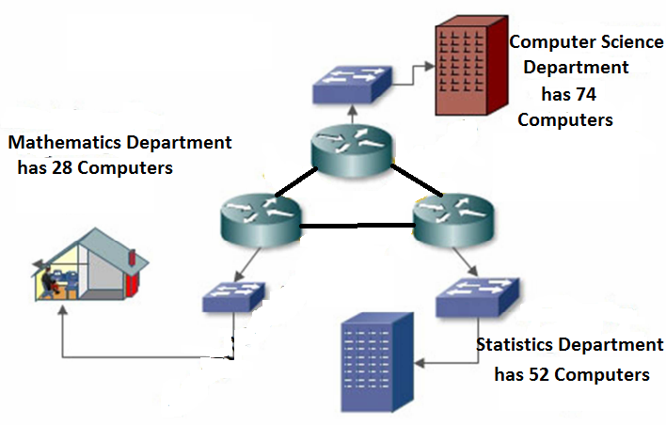

Fig. 4.1 Three departments from Faculty of Physical Sciences

Assuming Faculty of Physical Sciences the requirements given below was assigned the 192.168.1.0 subnet using VLSM:

* Computer Science department has 74 computers.
* Mathematics department has 52 computers.
* Statistics department has 28 computers.
* All the three departments were connected with each other via wan link.
* Each wan link requires two IP addresses.

Following the steps given in VLSM subnetting, Faculty of physical Sciences requires 6 subnets and 160 hosts.

**Step 1**:- Oder all segments according the hosts requirement (Largest to smallest).

|  |  |  |
| --- | --- | --- |
| Subnet | Segment | No. of Hosts |
| 1 | Computer Science | 74 |
| 2 | Mathematics | 52 |
| 3 | Statistics | 28 |
| 4 | WAN Link 1 | 2 |
| 5 | WAN Link 2 | 2 |
| 6 | WAN Link 3 | 2 |

**Step 2**:- Do Subnetting for largest segment. The largest segment needs 74 host addresses. /25 provide us two subnets with 126 hosts in each subnet.

192.168.1.0/25

|  |  |  |
| --- | --- | --- |
| Subnet1 | Subnet 2 | Subnet3 |
| Network ID | 192.168.1.0 | 192.168.1.128 |
| First Host Address | 192.168.1.1 | 192.168.1.129 |
| Last Host Address | 192.168.1.126 | 192.168.1.254 |
| Broadcast Address | 192.168.1.127 | 192.168.1.255 |

**Step 3:**- Assign subnet mask to the largest segment. As you can see in above table, subnet 1 fulfill the largest segment requirement. Assign it to our segment.

|  |  |
| --- | --- |
|  |  |
| Segment | Computer Science |
| Requirement | 74 |
| CIDR | /25 |
| Subnet mask | 255.255.255.128 |
| Network ID | 192.168.1.0 |
| First hosts | 192.168.1.1 |
| Last hosts | 192.168.1.126 |
|  |  |

**Step 4:** Do subnetting for second largest segment from next available subnet. Next segment requires 52 host addresses. Subnetting of /25 has given us two subnets with 128 hosts in each, from that we have assigned first subnet to Computer Science Department.

Now we would do the subnetting of Mathematics Department (second segment) with the capacity of 52 hosts.

So, /26 gives us 4 subnets with 62 hosts in each subnet.

192.168.1.0/26

Stopped here…. ☺

We cannot use subnet 1 and subnet 2 ( address from 0 to 127 ) as they are already assigned to Computer Science department. We can assign subnet 3 to our Mathematics department.

**Step 5:** Our next segment requires 28 hosts. From the above subnetting we have subnet 3 and subnet 4 available. Do subnetting for the requirement of 28 hosts.

192.168.1.0/27

Subnet Sub 1 Sub 2 Sub 3 Sub 4 Sub 5 Sub 6 Sub 7 Sub 8

Net ID 0 32 64 96 128 160 192 224

First

Host

1 33 65 95 129 161 193 225

Last

Host

30 62 94 126 158 190 222 254

Broadcast ID

31 63 95 127 159 191 223 255

Subnets 1 to 6 [address from 0 to 191] are already occupied by previous segments. We can assign subnet 7 to this segment.

Segment Administrative

Requirement 28

CIDR /27

Subnet mask 255.255.255.224

Network ID 192.168.1.192

First hosts 192.168.1.193

Last hosts 192.168.1.222

Broadcast ID 192.168.1.223

Step 6 :- Our last three segments require 2 hosts per subnet. Do subnetting for these.

192.168.1.0/30

Valid subnets are:-

0,4,8,12,16,20,24,28,32,36,40,44,48,52,56,60,64,68,72,76,80,84,88,92,96,100,104,108,112,116,120,124,128,132,136,140,144,148,152,156,160,164,168,172,176,180,184,188,192,196,200,204,208,212,216,220,224,228,232,236,240,244,248,252,256

From these subnets, subnet 1 to subnet 56 (Address from 0 - 220) are already assigned to previous segments. We can use 224,228, and 232 for wan links.

Subnet Subnet 57 Subnet 58 Subnet 59

Network ID 224 228 232

First host 225 229 233

Last host 226 230 234

Broadcast ID 227 231 235

Assign these subnets to wan links.

Wan Link 1

Segments Wan Link 1

Requirement 2

CIDR /30

Subnet mask 255.255.255.252

Network ID 192.168.1.224

First hosts 192.168.1.225

Last hosts 192.168.1.226

Broadcast ID 192.168.1.227

Wan Link 2

Segments Wan Link 2

Requirement 2

CIDR /30

Subnet mask 255.255.255.252

Network ID 192.168.1.228

First hosts 192.168.1.229

Last hosts 192.168.1.230

Broadcast ID 192.168.1.231

Wan link 3

Segments Wan Link 3

Requirement 2

CIDR /30

Subnet mask 255.255.255.252

Network ID 192.168.1.232

First hosts 192.168.1.233

Last hosts 192.168.1.234

Broadcast ID 192.168.1.235

We have assigned IP addresses to all segments, still we have 20 addresses available. This is one of the major advantages of using VLSM.

Exercises:

Q 1. If the following requirements: Physical Sciences (81), two WANLinks (3), Life Sciences (58) and Art (21), subnet the IP Address 192.168.58.0 using VLSM and list the remaining unused IP addresses, if any.