Department of Mathematics
Ahmadu Bello University, Zaria
Second Semester Examination 2010/2011
COSC 208: Introduction to Artificial Intelligence
Instruction: Answer any FOUR Questions. Time Allowed: 2 Hours

- Given the following knowledge:
Jumbo is an elephant. An elephant is big. An elephant is a mammal. A mammal is an animal. An animal is a living thing. A mouse is a mammal. A mouse is small. An elephant is gray. A mouse is gray. cucumber is a vegetable. A cucumber is green. A vegetable is a plant. A plant is a living thing. A poppy is a flower. Flower is a plant.
- Represents the knowledge using semantics network
- Represents the knowledge using frame

- Explain the concepts “forward searching” and “backward searching” and for each of them, state the characteristic of problems for which the searching technique can be efficient.
- Consider the search graph drawn below. The initial state is at the top(A), and goal states are represented by double circles. Note that arcs are directed. Which goal state is reached will depend on the search strategy applied. For each of the search strategies listed below, indicate which goal state is reached (if any) and list, in order, the states explored. Assume that the NEXT-STATES function returns a state’s successors in the same left-to-right order as in the search graph
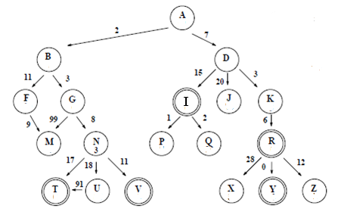
- Depth first search
- Breath first search
- Best first search

- Describe the operation of case based reasoning (CBR) and state the characteristics of problems domain in which CBR can be suitable.
- Given the following rules in a “backward-chaining” expert system application:
If (A AND B) THEN C (with CF=0.9)
If (C OR D) THEN E (with CF=0.75)
If (F AND G)THEN A (with CF=0.6)
If D THEN G (with CF=0.8)
Evaluate the certainty factor (CF) of E assuming the system can conclude the following facts with confidence.
CF(F)=0.9
CF(B)=0.8
CF(D)=0.7

- Explain the Turing test concept and state it significance
- The missionaries and cannibals problem involves three missionaries and three cannibals that find themselves together on one side of the river. They wish to cross to the other side of the river using a boat that can carry only two persons. Assuming, the missionaries are safe so far their number is greater than or equal to the number of cannibals whenever they are together.
- Represent the problem as a state problem and identify the initial state and the goal state.
- Identify the operators that can be used in solving this problem.
- By using Backward searching, show how the system can arrive at the goal state.

- One of the bottlenecks in building knowledge based system is knowledge acquisition. Explain what you understand by knowledge acquisition and state the problems encountered by knowledge builders in building knowledge base system.

- Consider the following rules:
Rule 1: IF interest rise THEN stock fall
Rule 2: IF interest fall THEN stock rise
Rule 3: IF naira fall THEN interest fall
Rule 4: IF naira rise THEN interest rise
Rule 5: IF stock fall THEN inflation rise
Rule 6 IF fedmont add AND tax fall THEN naira rise
While reasoning under uncertainty using the method based on probability, find the probability that “stock fall” knowing that “interest rise” . Assume the following probability values:
P(interest rise/stock fall)=0.6 P(stock fall) =0.7
P(interest rise/¬ stock fall)=0.4 P(¬ stock fall)=0.3

- Convert each of the following English sentences into First-Order Predicate Calculus , using reasonably named predicates, functions, and constants.
- All birds can fly except for penguins and ostriches or unless they have a broken wing.
- All pianists and conductors know a piece written by Mozart
- There is a student in ABU who was born in a country in Lagos state
- Cats rule and dogs drool
- Only those trees that are tall have long roots
- All children, when healthy, like ice cream
- Convert the following into a correct and meaningful English language sentences
- ∀x IsABunny(x) ⇒ IsCute(x)
- ∀x IsABunny(x) ∧ IsAStudent(x) ∧ IsTaking(x, COSC204) ⇒ IsCute(x) ∧ IsCool(x)
- ∃s ∀h IsAStudent(s) ∧IsTaking(s,COSC204)∧HomeworkFor(h,COSC204)∧¬Hates(s,h)
- ∃x book(x) ∧ owner(x, Sue) → missing(x)

