KING FAHD UNIVERSITY OF PETROLEUM & MINERALS

Information and Computer Science Department

ICS-201 Introduction to Computer Science

Lab 11: Event Driven Programming - II

Objectives: In this lab, the following topics will be covered

- Text Fields and Text Areas.
- Layout Managers (BorderLayout and GridLayout)
- Applets
- MouseListeners.
- Menus.
- Exercises.

Text Fields are text boxes that accommodates text. Example of text fields are the user name and user password fields used when u log in to your e-mail.

Java has a defined component class JTextField that can be created as follows

JTextField jta = new JTextField (10);

were 10 is the number of characters that can be visible in the text field. The text at the JText field can be returned using the method getText(). It can also be set using the method setText(String s).

like other components, we can change the color and the font of the text field.
Example 1
class LabExample extends JFrame
{
JTextField jta = new JTextField(10);
Font fnt = new Font("Times new roman",Font.BOLD,20);
LabExample()
{
super("Example");
setLayout(new FlowLayout());
setSize(250,100);
add(jta);
jta.setForeground(Color.PINK);
jta.setFont(fnt);
setVisible(true);
}

public static void main(String[]args)
{
new LabExample();
}
}

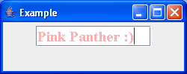
Important Note
It is the responsibility of the programmer to check for errors when the input expected in the JTextField is a number. The compiler will not catch such error unless handled by the user.

Run the following example and observe the result when the input number is not in the correct format:
Example2
import java.awt.*;
import java.awt.event.*;
import javax.swing.*;

class LabExample extends JFrame
{
JTextField jta1 = new JTextField(10);
JTextField jta2 = new JTextField(10);
JButton button = new JButton(" Add them up");

Font fnt = new Font("Times new roman",Font.BOLD,20);

LabExample()
{
super("Example");
setLayout(new FlowLayout());
setSize(250,150);
add(new JLabel("1st Number"));
add(jta1);
add(new JLabel("2nd Number"));
add(jta2);
add(button);

button.addActionListener(new ActionListener()
{
public void actionPerformed(ActionEvent ae)
{
try
{
double x1 = Double.parseDouble(jta1.getText().trim());
double x2 = Double.parseDouble(jta2.getText().trim());

JOptionPane.showMessageDialog(null, "Result = "+(x1+x2),"Alert",JOptionPane.INFORMATION_MESSAGE);

}
catch(Exception e)
{
JOptionPane.showMessageDialog(null, "Error in Numbers !","alert" , JOptionPane.ERROR_MESSAGE);
}
}
});

setVisible(true);
}

public static void main(String[]args)
{
new LabExample();
}
}

JTextArea

TextAreas are similar to TextFields but they have more than one line. Examples of TextArea are those that we use in the body of e-mail messages

Example3
import java.awt.*;
import java.awt.event.*;
import javax.swing.*;

class TextAreaExample extends JFrame
{
JTextArea jta1 = new JTextArea(10,25);
JButton button = new JButton("Add some Text");
public TextAreaExample()
{
super("Example");
setSize(300,300);
setLayout(new FlowLayout());
add(jta1);
add(button);
button.addActionListener(new ActionListener()
{
public void actionPerformed(ActionEvent ae)
{
String txt = JOptionPane.showInputDialog(null,"Insert some text");
jta1.append(txt);
}
});
}
public static void main(String[]args)
{
new TextAreaExample().setVisible(true);
}
}

Note
We can easily add the possibility of scrolling a text area by adding it to a container named JScrollPane as follows:
JTextArea txtArea = new JTextArea(20,20)
JScrollPane jScroll = new JScrollPane(txtArea);
// …
add(Scroll); // we add the scrollPane and not the text area.

Try it !

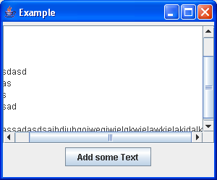
Layout Managers:

BorderLayout:

Divides the component into regions (WEST, EAST, NOTH, SOUTH and Center). Components can be added to any of those fives components.

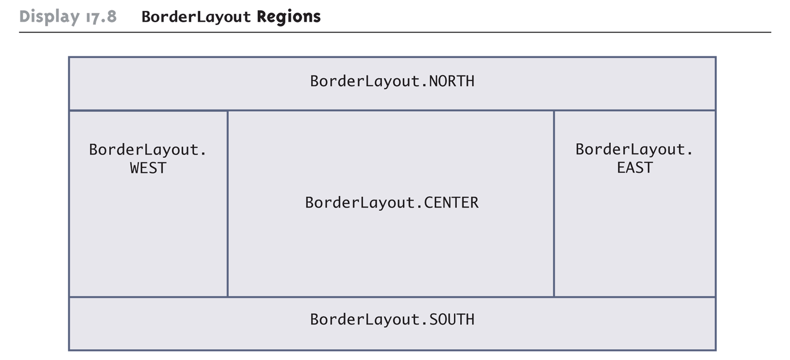

The add method to a container that has a BorderLayout is different and looks like the following:

add( comp , BorderLayout.EAST);

Note that we can add JPanel to these regions and add components to those panels. We can set the layout of those JPanel to another layout.

GridLayout

In GridLayout, the component take a tabular form, with a number of rows and number of columns.
1 | 2 | 3 | 4
5 | 6 | 7 | 8
9 | 10 | 11 | 12

If the component has a GridLayout of 3 rows and 4 columns then components will take the form of the table shown above and will be added in the order they are listed.

The following example illustrates a mixture of components layout
Example4
import javax.swing.*;
import java.awt.*;
import java.awt.event.*;

class BorderExample extends JFrame
{
JPanel[] pnl = new JPanel[12];

public BorderExample()
{
setLayout(new GridLayout(3,4));
for(int i = 0 ; i < pnl.length ; i++)
{
int r = (int) (Math.random() * 255);
int b = (int) (Math.random() * 255);
int g = (int) (Math.random() * 255);
pnl[i] = new JPanel();
pnl[i].setBackground(new Color(r,g,b));
add(pnl[i]);
}

pnl[4].setLayout(new BorderLayout());
pnl[4].add(new JButton("one"),BorderLayout.WEST);
pnl[4].add(new JButton("two"),BorderLayout.EAST);
pnl[4].add(new JButton("three"),BorderLayout.SOUTH);
pnl[4].add(new JButton("four"),BorderLayout.NORTH);
pnl[4].add(new JButton("five"),BorderLayout.CENTER);

pnl[10].setLayout(new FlowLayout());
pnl[10].add(new JButton("one"));
pnl[10].add(new JButton("two"));
pnl[10].add(new JButton("three"));
pnl[10].add(new JButton("four"));
pnl[10].add(new JButton("fve"));

setSize(800,500);
}
public static void main(String[]args)
{
new BorderExample().setVisible(true);
}
}

Which will have the following output
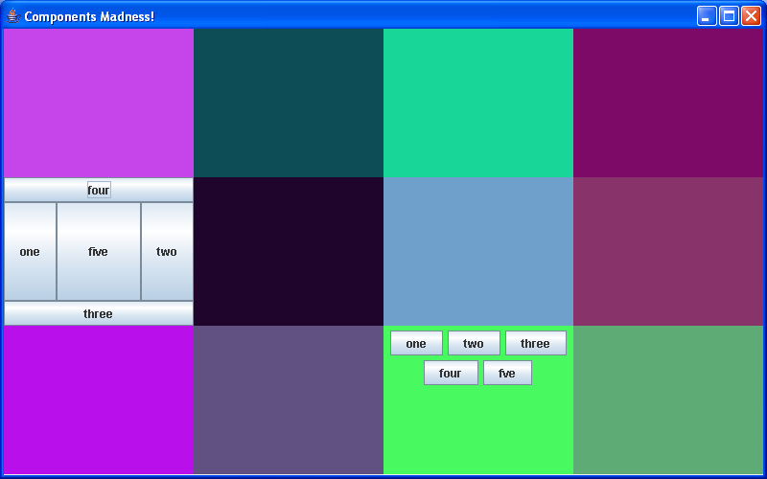
Note that the JFrame has a GridLayout of 3 by 4 while the JPanel at (2, 1) has a BorderLayout. The JPanel at (3, 3) has a FLowLayout.

Null Layout Manager
Sometimes you may want to fix the size and the location of the component within a container. Hence, you should tell the program not to use any Layout manager ( setLayout(null) )

So that we will get something like:
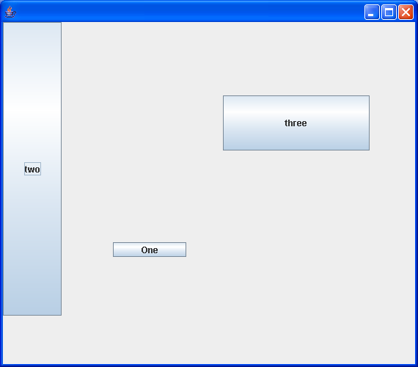

Example5

import javax.swing.*;
import java.awt.*;
import java.awt.event.*;

class NullLayout extends JFrame
{
JButton but1 = new JButton("One");;
JButton but2 = new JButton("two");;
JButton but3 = new JButton("three");;

public NullLayout()
{
setLayout(null);
but1.setBounds(150,300,100,20); // added at 150,300 width = 100, height=20
but2.setSize(80,400); // added at 0,0 width = 80, height=400
but3.setLocation(300,100);
but3.setSize(200,75);
// those two steps can be combined in one setBounds method call
add(but1);
add(but2);
add(but3);
setSize(500,500);
}
public static void main(String[]args)
{
new NullLayout().setVisible(true);
}
}
Applets

Applet is a word used for small application. In Java we can create stand alone application and applets. Applets need to be run in an environment like a web browser.

After compiling the applet file, the resulting .class file can be embedded in an HTML page

<applet code="AppletExample.class" width=250 height=300></applet>

Then when opening the webpage with the browser (for example Internet Explorer) the applet will be run with the width =250 and height = 300

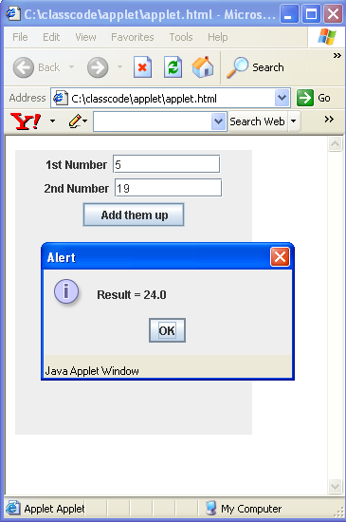

And the following is the modified code of example2 to change the application into an applet:
import java.awt.*;
import java.awt.event.*;
import javax.swing.*;

public class AppletExample extends JApplet
{
JTextField jta1 = new JTextField(10);
JTextField jta2 = new JTextField(10);
JButton button = new JButton(" Add them up");
public void init()
{
setLayout(new FlowLayout());
setSize(250,150);
add(new JLabel("1st Number"));
add(jta1);
add(new JLabel("2nd Number"));
add(jta2);
add(button);
button.addActionListener(new ActionListener()
{
public void actionPerformed(ActionEvent ae)
{
try
{
double x1 = Double.parseDouble(jta1.getText().trim());
double x2 = Double.parseDouble(jta2.getText().trim());
JOptionPane.showMessageDialog(null, "Result = "+(x1+x2),"Alert",JOptionPane.INFORMATION_MESSAGE);
}
catch(Exception e)
{
JOptionPane.showMessageDialog(null, "Error in Numbers !","alert" , JOptionPane.ERROR_MESSAGE);
}
}
});
setVisible(true);
}
}
MouseListener

We can implement mouse listeners and key listeners on components. The interface MouseListener has the following methods:

Method Summary
void | mouseClicked(MouseEvent e)  Invoked when the mouse button has been clicked (pressed and released) on a component.
void | mouseEntered(MouseEvent e)  Invoked when the mouse enters a component.
void | mouseExited(MouseEvent e)  Invoked when the mouse exits a component.
void | mousePressed(MouseEvent e)  Invoked when a mouse button has been pressed on a component.
void | mouseReleased(MouseEvent e)  Invoked when a mouse button has been released on a component.

The MouseListener can be added to componens as follows:

Component.addMouseListener(listener);

Where listener is an instance of a class that implements the interface MouseListener. Note that it should provide implementation of all the methods in the table.

Example6
import java.awt.*;
import java.awt.event.*;
import javax.swing.*;

class MyMouse extends JFrame
{
JLabel lbl = new JLabel("");
public MyMouse()
{
super("Dude! Where's my mouse ?");
setSize(400,400);
setLayout(new BorderLayout());
add(lbl,BorderLayout.SOUTH);
addMouseListener(new MouseListener()
{
public void mouseExited(MouseEvent a){}
public void mouseClicked(MouseEvent a) {lbl.setText("X="+a.getX()+" Y="+a.getY());}
public void mouseEntered(MouseEvent a) {}
public void mouseReleased(MouseEvent a) {}
public void mousePressed(MouseEvent a) {}

});
}
public static void main(String[]args)
{
new MyMouse().setVisible(true);
}
}

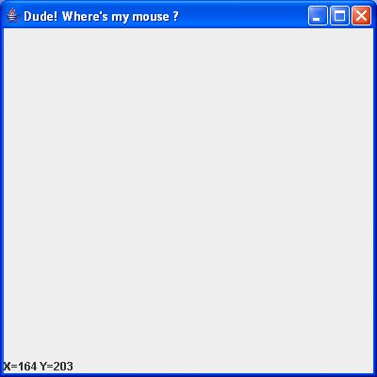
Menus

Adding menus to a java program is simple. Java defines three components to handle those

- JMenuBar: which represent the component that holds the menus.
- JMenu: which represent a menu of items to select from.
- JMenuItem: which represents an Item that can be clicked from a Menu.

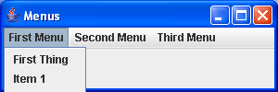

Similar to Button (in fact MenuItems are subclasses of the AbstractButton class). We can add an ActionListener to them just like we did with buttons.

Exercises
- Implement a guessing game that has one text field and one button. It will ask the user to guess a number between 0-20 and gives him three trials. If he does not succeed it will tell the user made a mistake in the guess and that the number is smaller/larger. If the user consume three times of guessing the program should terminate with appropriate message. If the user got the right guess, then the program should terminate with an appropriate message.

- Implement a Java application that has a border layout and labels for each region in the layout. Now defined mouse event to act as the following:
  - When mouse enters CENTER the program shows a dialog (Welcome to Riyadh)
  - When mouse enters WEST the program shows a dialog (Welcome to Jeddah)
  - When mouse enters SOUTH the program shows a dialog (Welcome to Abha)
  - When mouse enters NORTH the program shows a dialog (Welcome to Hail)
  - When mouse enters EAST the program shows a dialog (Welcome to Dhahran)

- Implement a java program with a JTextArea and Two Menus:
  - Color: which has three Items: Blue, Red, and Black
  - Font: Which has three fonts: “Times New Roman”, “MS Sans Serif”, “Courier New” and “Bodoni MT Black”

You should be able, by using the menus to change the font and the color of the text written in the JTextArea.

