King Fahd University of Petroleum & Minerals
Information & Computer Science Department
ICS201 INTRODUCTION TO COMPUTER SCIENCE

LAB # 09: Java Collections Framework

Objectives:
In this lab we shall look at how the Java Collections framework handles collections, Specifically we concentrate on the ArrayList class. In general, an ArrayList serves the same purpose as an array, except that an ArrayList can change length while the program is running. An iterator is an object that is used with a collection to provide sequential access to the collection elements. This access allows examination and possible modification of the elements. An iterator imposes an ordering on the elements of a collection even if the collection itself does not impose any order on the elements it contains. If the collection does impose an ordering on its elements, then the iterator will use the same ordering
Introduction to Java Collections framework
• A collection is a group of objects.
• The Java collections framework standardizes the way in which groups of objects are handled by a program.
• The collections framework defines several interfaces and classes in the java.util package. Some of these are:

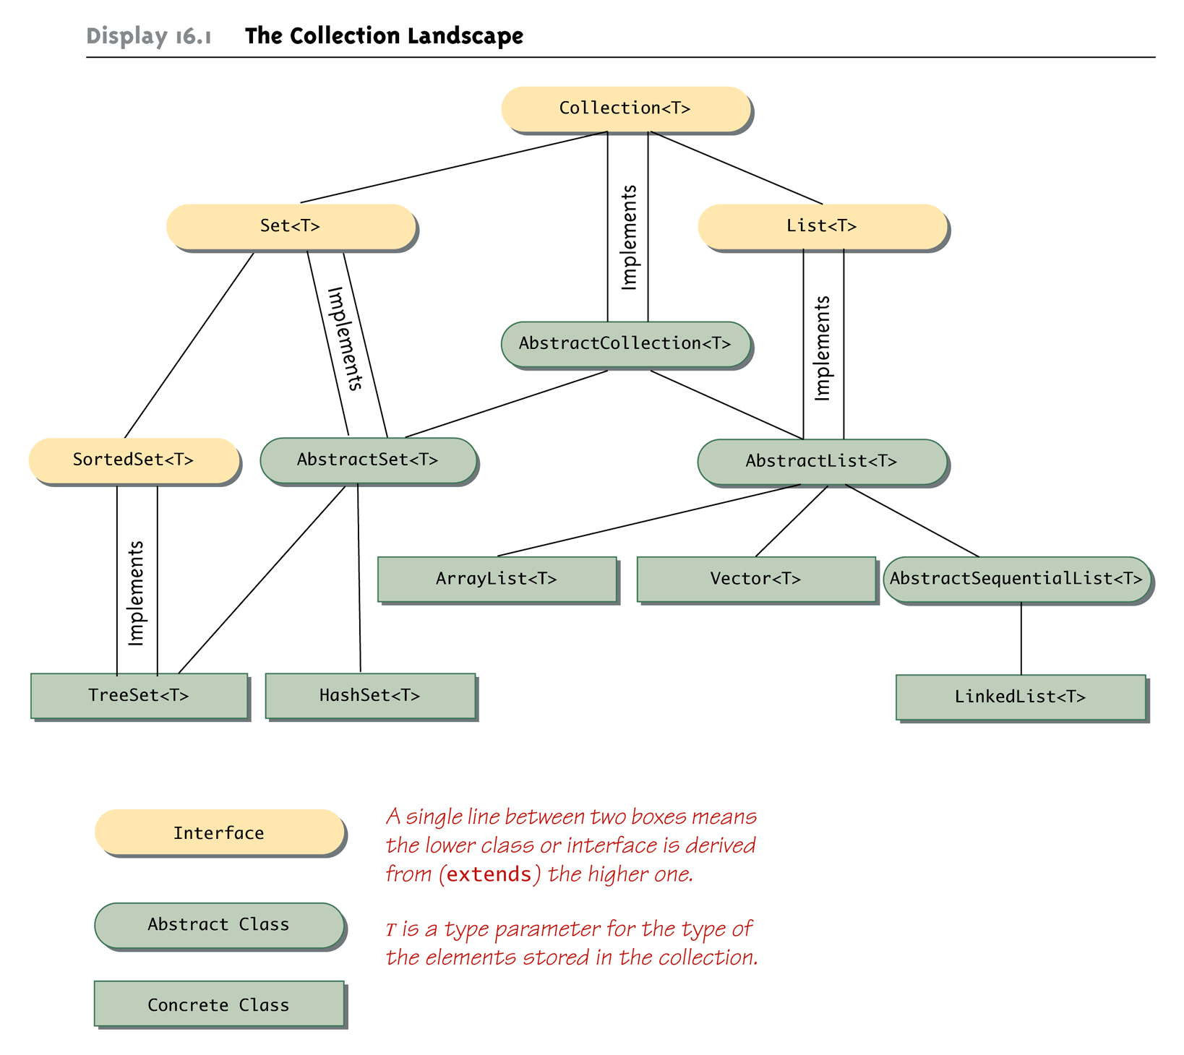

Interface | Description
Collection <T> | Declares the core methods that all collections will have.
List <T> | Extends Collection to handle sequences (lists of objects of type T). Classes that implement the List<T> interface have their elements ordered as on a list.
Set <T> | Classes that implement the Set<T> interface do not allow an element in the class to occur more than once
Iterator <T> | Defines the necessary methods to iterate through the elements of a collection.
ListIterator <T> | Extends the functionality of the Iterator interface to include two-way traversal of the List as well as the ability to modify elements.

• Methods of the Iterator interface

public boolean hasNext( ) | Returns true if there is another element in the invoking collection object still to be visited by the iterator
public T next( ) | Returns the next element in the invoking collection object. Throws NoSuchElementException if there is no next element.
public void remove( ) | Removes from the collection the last element returned by the method next. It throws IllegalStateException if an attempt is made to call remove( ) that is not preceded by a call to next( ). Each valid call to remove has to be preceded by a call to next.

To visit all the elements of a collection c containing Integer objects, code such as the following may be used:
Iterator <Integer> iter = c.iterator( );  while(iter.hasNext( )) {  Integer obj = iter.next( );  process(obj);  } | or | for(Iterator<Integer> i=c.iterator( );  i.hasNext( ); ) {  process(i.next( ));  }

Note: When next( ) is invoked, the iterator jumps over the next element, and it returns a reference to the object that it just passed.

The remove( ) method of an iterator removes the element whose reference was returned by the last call to next( ). For example, the following code removes the first element in a collection c of Strings:

Iterator <String> it = c.iterator( ); // sets the iterator to the beginning (first) of the collection
it.next( ); // jumps over the first element
it.remove( ); // removes the first element because it is the one returned by the previous next

It is illegal to call the remove( ) method of an iterator if it was not preceded by a call to next( ). For example, the following is invalid:

Iterator <String> it = c.iterator( );
it.remove( );

Also in the following code, the second remove() call is invalid. It will generate a run time exception
IllegalStateException.

Iterator <String> it = c.iterator( );
it.next( );
it.remove( ); // valid
it.remove(); // not valid

• Methods of the ListIterator interface
The list interface applies to classes that implement the List<T> interface. The listInterface object can move forward and backward.

public boolean hasNext( ) | Returns true if there is a next element in the invoking list object.
public boolean hasPrevious( ) | Returns true if there is previous element in the invoking list object.
public T next( ) | Returns the next element in the invoking collection object. Throws NoSuchElementException if there is no next element.
public T previous( ) | Returns the previous element in the invoking list object. Throws NoSuchElementException if there is no previous element.
public int nextIndex( ) | Returns the index of the next element. If there is no next element, returns the size of the list.
public int previousIndex( ) | Returns the index of the previous element. If there is no previous element, returns –1.
public void add(T newElelem) | Inserts a new object into the list, immediately before the object whose reference would be returned by a subsequent call to next( ). If the list is empty, the new object is added at the beginning of the list. The element added will returned by a call to the method previous.
public void remove() | Removes from the list the last element whose reference was returned by a call to next( ) or previous( ). An IllegalStateException is thrown if remove( ) is called without being preceded by a call to next( ) or previous( ).
public void set(T newEl) | Replaces the last element returned by next or previous by the element newel. Cannot be used if there has been a call to add or remove after calling next or previous.

The add( ) method of a ListIterator adds a new element before the current listIterator position. Thus, calling add( ) does not affect the value returned by next( ); however if you call previous( ) immediately after calling add( ), the method returns a reference to the object that was just added.

Example1:
The program below outputs: [0, 25, 1, 2, 3, 4, 5]

import java.util.*;
class TestListIterator {

public static void main(String[] args) {

ArrayList <Integer> list = new ArrayList<Integer> ();
ListIterator<Integer> iter = list.listIterator();
for(int i = 0; i < 6; i++)
iter.add(new Integer(i));

iter = list.listIterator();// reset to the beginning of the list
iter.next(); // jump over the first element
iter.add(new Integer(25)); //add immediately after the first
System.out.println(list); // using toString of the ArrayList
System.out.println("The elements using the new for loop");
for (Integer i :list)
System.out.println(i);
}
}
The set( ) method of a ListIterator replaces the last element whose reference was returned by a call to next( ) or previous( ) with a new element. For example, the following code replaces the first element in a list with a new value:
// . . .
ListIterator <T> iterator = list.listIterator( );

T oldValue = iterator.next( );
// . . .
iterator.set(newValue);

The ArrayList class

• The ArrayList class implements the List interface in terms of a doubly linked list. It allows list objects of any type, including null.
• Methods defined in the ArraydList class and those it inherits:

1. ArrayList constructors

public ArrayList ( ) | Creates an ArrayList<T> of default initial capacity of 10.
public ArrayList(Collection <? Extends T> c) | Creates an ArrayList<T> that contains all the elements of the collection c in the same order as they are in c.
public ArrayList (int initialCapacity ) | Creates an ArrayList<T> with the specified capacity.

2. Methods to iterate an ArrayList

public Iterator <T> iterator( ) | This method is inherited from the AbstractSequentialList class. It returns an iterator to the start of the invoking arrayList object.
public ListIterator <T> listIterator( ) | This method is inherited from the AbstractList class. It returns a list iterator to the start of the invoking ArrayList object.
public ListIterator<T> listIterator(int index) | Returns a list iterator to the invoking list that begins at the specified index. The first element to be returned by next is the element at index. 0<=index<=size()

The listIterator can move forward and backward for visiting the elements of the list. An example of a listIterastor moving backward from the end of the list is shown below:
ListIterator <Integer> iter = c.listIterator(c.size() );
while(iter.hasPrevious( )) {
Integer obj = iter.previous( );
process(obj);
}

3. Methods to add elements to an ArrayList<T> object

public boolean add(T newEl) | Inserts newEl to the end of the invoking ArrayList<T> object.
public void add(int index, T newEl) | Inserts newEl at position index in the invoking ArrayList object and increases the size of the calling object by 1. Any preexisting elements at and beyond the point of insertion are shifted by one location. Thus, their indices are increased by 1.
public boolean addAll(Collection <? Extends T> c) | Appends all the elements in c to the end of the elements in the calling arrayList object.
public boolean addAll(int index, Collection <? Extends T> c) | Inserts all the elements in c in the calling object starting at position index

Note: Instead of using the add( ) method of an Arraylist object, one may use, as we saw before, the add( ) method of a ListIterator object to add a new object to an ArrayList object.

Example of using the add( ) method of a linked list object:
ArrayList<Integer> list = new ArrayList<Integer> ();
for(int i = 0; i < 6; i++)
list.add(new Integer(i));

4. Methods to remove elements from an ArrayList

public void clear( ) | Removes all the elements from the invoking ArrayList object.
public boolean removeAll(Collection<?> c) | This method is inherited from the AbstractCollection class. It removes from the invoking list object all the elements contained in collection c. Returns true if the calling object is modified.
public boolean retainAll(Collection c) | This method is inherited from the AbstractCollection class. It retains only the elements in the calling object that are also contained in the collection c. It returns true if the calling object was changed
public boolean remove(Object obj ) | Removes the first occurrence of obj from the invoking ArrayList object. Returns true if the element was successfully removed. The remaining elements beyond the point of removal are shifted to the left. If the element is not present, false is returned.
public T remove(int index) | Deletes the element at the specified index and returns the deleted element. The size of the calling object will be decreased by 1. Elements after the removed elements are shifted and their indices are reduced by 1. 0=<index< size()
public E set(int index, E el) | Replaces the element at the specified position (index) in this list with the specified element el. It returns the replaced element.
public void clear() | Removes all of the elements from this list. The list will be empty after this call returns.

Note: Instead of using the remove( ) method of an ArrayList object, one may use the remove( ) method of either an iterator object or a listIterator object to remove an element from a linked list:

Iterator<T> it = list.iterator( );
it.next( ); // skip over the first element
it.remove( ); // remove the first element

5. Methods to retrieve element from an ArrayList

public T get(int index) | Returns the object at position index in the invoking ArrayList object.
List<E> subList(int fromIndex,  int toIndex) | Returns a view of the portion of this list between the specified fromIndex, inclusive, and toIndex, exclusive

6. Methods to investigate the contents of an ArrayList.

public boolean contains(Object obj) | Returns true if the invoking ArrayList object contains the object obj; otherwise it returns false.
public boolean containsAll(Collection <?> c) | This method is inherited from the AbstractCollection class. It returns true if the invoking list object contains all of the elements of collection c.
public boolean equals(Object obj) | Returns true if and only if the specified object is also a list, both lists have the same size, and all corresponding pairs of elements in the two lists are equal
public boolean isEmpty( ) | This method is inherited from the AbstractCollection class. It returns true if the invoking list object is empty.
public int IndexOf(Object obj) | Returns the index of the first occurrence of obj in the invoking List object, or –1 if the object does not contain obj.
public int lastIndexOf(Object obj) | Returns the index of the last occurrence of obj in the invoking List object, or –1 of the object does not contain obj.
public int size( ) | Returns the number of objects in the invoking ArrayList object.

7. Methods to return an array containing the elements of the ArrayList.

public Object[ ] toArray( ) | Returns an array containing all of the elements in this list in the correct order.
Public <T> T[ ] toArray(T[ ] array) | Returns an array containing all of the elements in this list in the correct order; the runtime type of the returned array is that of the specified array.

8. Methods to indicate the size and capacity of the arraylist

public int size() | Returns the number of elements in this list.
public void ensureCapacity (int minCapacity) | Increases the capacity of this ArrayList instance, if necessary, to ensure that it can hold at least the number of elements specified by the minimum capacity argument.

Example 2

import java.util.*;
class SplitList {
public static void main(String[] args) {
ArrayList <Integer>a=new ArrayList<Integer>();
ArrayList<Integer>b=new ArrayList<Integer>();
ArrayList <Integer>c=new ArrayList<Integer>();
Random rd=new Random();
for (int i=0;i<20;i++)
a.add(new Integer(rd.nextInt(101)-50)); // generates a random number between -50 and 50

// Go over the elements of a and split them. Put negative numbers in b and positive numbers in c.
// Once done, use the new for loop to print the elements of each arrayList.
Iterator<Integer> ia = a.iterator(); // iterator for arrayList a
while (ia.hasNext()) {
int x= ia.next(); // automatic unboxing
if(x<0)
b.add(x); // automatic boxing
else
c.add(x); // automatic boxing
}
System.out.println("The original list");
for (Integer i: a)
System.out.println(i);
System.out.println("The list of negative numbers");
for (Integer i: b)
System.out.println(i);
System.out.println("The list of positive numbers");
for (Integer i: c)
System.out.println(i);
}}

Exercise 1
The Sieve of Eratosthenes is a classic algorithm to find all primes numbers between 2 and n. The algorithm is as follows:

1-Begin with an Arraylist of integers from 2 to n.
2-The first integer, 2, is the first prime.
3- Go over the remaining elements and remove every multiple of this prime number.
4- take the next integer as the next prime number and repeat step 3.
5- stop the algorithm when the next prime number is greater than $\sqrt{n}$
After all removals are done, the remaining numbers are prime numbers between 2 and n.
Implement the above algorithm using an arrayList with numbers from 2 to 100. After finding the prime numbers, print them.

Exercise 2
Develop an application that maintains a linked list of books. The class Book has a book number, title, and author. Your application displays one book at a time. You should have options for displaying the next book, displaying the previous book, adding a new book, removing the displayed book, and updating the displayed book. Use an arrayList to store your book objects.

