Ahmadu Bello University, Zaria

Department of Mathematics

**2009/2010 Second Semester Examination**

**COSC 406: Advanced Database Systems**

**Date**: October 6, 2010 **Time Allowed**: 120 Minutes

**Instructions**:

1. Attempt ANY FOUR questions.
2. Write all your answers in the spaces provided on this Question Paper.

**Student’s Registration Number**:………………………………………………………………… **Signature**:……………………………………..

**Date of Examination**:…………………………………………………………………………………**Time**:………………………………………………

**Scores**:

|  |  |  |
| --- | --- | --- |
| **Question** | **Maximum Scores** | **Scores Obtained** |
| 1 | 20 |  |
| 2 | 20 |  |
| 3 | 20 |  |
| 4 | 20 |  |
| 5 | 20 |  |
| **Total** | **80** |  |

DRAFT SOLUTION

1. Answer both part (a) and (b) of the following questions:
   1. (**10 marks**). Study each of the following statements carefully and indicate whether each is true or false. One mark each.

|  |  |  |
| --- | --- | --- |
| **S/No.** | **Statement** | **True or false?** |
| 1 | Each cell of relation may contain several values from the same domain. | True |
| 2 | Each attribute has a distinct name. | True |
| 3 | Values of an attribute are all from the same domain. | True |
| 4 | Order of attributes has some significance. | True |
| 5 | Physical data independence refers to immunity of the conceptual schema to  changes in the internal schema. | False |
| 6 | Order of tuples has no significance, theoretically. | True |
| 7 | Four basic (ACID) properties of a transaction are: Automatic, Controllable, Integrity  and Durability | False |
| 8 | Functional Dependency describes the relationship between attributes in different  relations | False |
| 9 | First Normal Form (1NF) is a relation in which the intersection of each row and  column contains one and only one value | False |
| 10 | With NOT NULL, system rejects any attempt to insert a null in the column. | False |

* 1. (**10 marks**). Study each of the explanations in the right-hand table below and match it against the most appropriate term from the left-hand table. Write the corresponding number of the term in the left-hand table to the left of the matching explanation in the right-hand table. One mark each.

|  |  |  |  |
| --- | --- | --- | --- |
| **Term** |  | **Matching ID** | **Definition** |
| 1 – A relation |  | 2 | is a named column of a relation. |
| 2 – Attribute |  | 3 | is a set of allowable values for one or more attributes. |
| 3 – Domain |  | 4 | is a number of tuples in a relation. |
| 4 – Degree |  | 5 | is a number of attributes in a relation. |
| 5 – Cardinality |  | 1 | is a table with columns and rows. |
| 6 – View |  | 6 | Dynamic result of one or more relational operations operating on the base relations to produce another relation. |
| 7 – Foreign key |  | 7 | An attribute or set of attributes within one relation that  matches candidate key of some (possibly same) relation. |
| 8 – Entity integrity |  | 10 | A named relation, corresponding to an entity in conceptual schema, whose tuples are physically stored in database. |
| 9 – Referential integrity |  | 9 | In a base relation, no attribute of a primary key can be null. |
| 10 – Base relation |  | 8 | If foreign key exists in a relation, either the foreign key value must match a candidate key value of some tuple in its home relation or foreign key value must be wholly null. |

1. (**20 marks**). Use the following relations to answer the questions that follow.

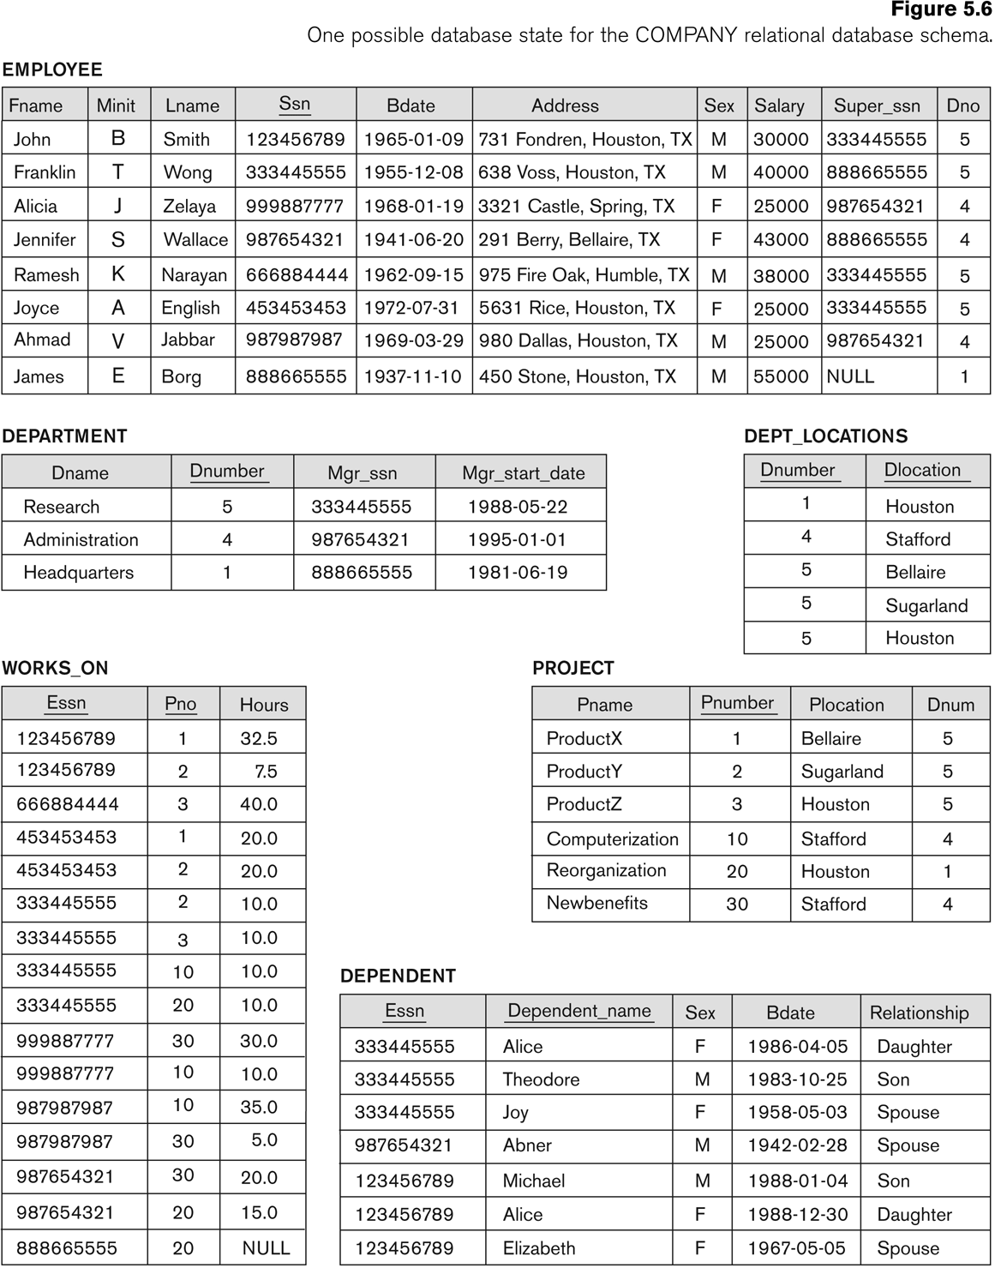

Write relational algebra expressions to answer the following queries.

1. (**4 marks**). To retrieve the first name, last name, and salary of all employees who work in department number 5.

|  |
| --- |
| $π_{FNAME,LNAME,SALARY}(σ_{DNO=5}\left(EMPLOYEE\right))$ OR $$DEP5EMPS ← σ_{DNO=5}\left(EMPLOYEE\right)$$ $$RESULT ←π_{FNAME,LNAME,SALARY}\left(DEP5EMPS\right)$$ |

1. (**4 marks**). To retrieve the social security numbers of all employees who either work in department 5 or directly supervise an employee who works in department 5.

|  |
| --- |
| $$DEP5EMPS ← σ_{DNO=5}\left(EMPLOYEE\right)$$ $$RESULT1 ←π_{SSN}\left(DEP5EMPS\right)$$ $$RESULT2 ←π_{SUPERSSN}\left(DEP5EMPS\right)$$ $$RESULT ←RESULT1 ∪ RESULT2$$ |

1. (**4 marks**). Write the result of the following relational algebra query:

|  |
| --- |
| fig06_07 |

1. (**4 marks**). Write the result of the following relational algebra query:

$$ρ_{R\left(Dno,NoOfEmployees,AvaerageSal\right)}(_{Dno}I_{COUNT Ssn, AVERAGE Salary}\left(EMPLOYEE\right))$$

|  |  |  |  |  |  |  |  |  |  |  |  |  |
| --- | --- | --- | --- | --- | --- | --- | --- | --- | --- | --- | --- | --- |
| R   |  |  |  | | --- | --- | --- | | Dno | NoOfEmployees | AverageSal | | 5 | 4 | 33250 | | 4 | 3 | 31000 | | 1 | 1 | 55000 | |

1. (**4 marks**). Given R and S below, show the result of: $T ←R ÷S$

|  |  |  |  |
| --- | --- | --- | --- |
| A | B |  | A |
| a1 | b1 |  | a1 |
| a1 | b2 |  | a2 |
| a1 | b3 |  | a4 |
| a1 | b4 |  |  |
| a2 | b1 |  |  |
| a2 | b3 |  |  |
| a2 | b4 |  |  |
| a3 | b1 |  |  |
| a3 | b2 |  |  |
| a3 | b4 |  |  |
| a4 | b1 |  |  |
| a4 | b3 |  |  |

|  |  |  |  |
| --- | --- | --- | --- |
| |  | | --- | | B | | b1 | | b3 |   T |

1. (**20 marks**). Consider the following information about a university database:

* Professors have an SSN, a name, an age, a rank, and a research specialty.
* Projects have a project number, a sponsor name (e.g., NSF), a starting date, an ending date, and a budget.
* Graduate students have an SSN, a name, an age, and a degree program (e.g., M.S. or Ph.D.).
* Each project is managed by one professor (known as the project’s principal investigator).
* Each project is worked on by one or more professors (known as the project’s co-investigators).
* Professors can manage and/or work on multiple projects.
* Each project is worked on by one or more graduate students (known as the project’s research assistants).
* When graduate students work on a project, a professor must supervise their work on the project. Graduate students can work on multiple projects, in which case they will have a (potentially different) supervisor for each one.
* Departments have a department number, a department name, and a main office.
* Departments have a professor (known as the chairman) who runs the department.
* Professors work in one or more departments, and for each department that they work in, a time percentage is associated with their job.
* Graduate students have one major department in which they are working on their degree.
* Each graduate student has another, more senior graduate student (known as a student advisor) who advises him or her on what courses to take.

Design and draw an ER diagram that captures the information about the university. Use only the basic ER model here; that is, entities, relationships, and attributes. Be sure to indicate any key and participation constraints.

|  |
| --- |
| * + - * + 5 marks for each of the classes Professor, Dept, project and Graduate |

1. Study each of the following schema diagrams carefully.
   1. (**10 marks**). Map the following ER schema into a relational schema indicating all primary keys and foreign keys.

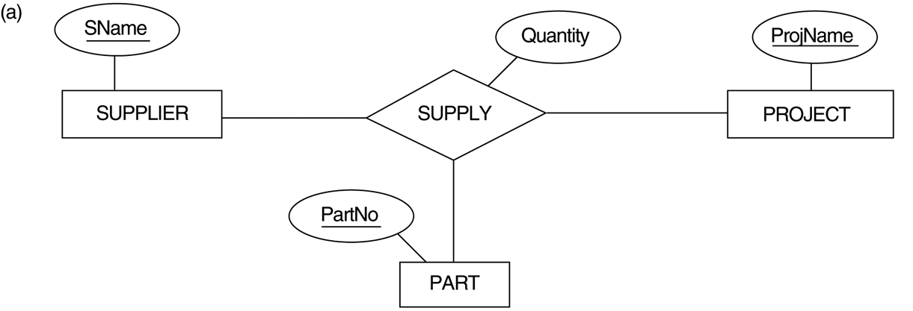

|  |
| --- |
| fig07_04 |

* 1. (**10 marks**). Map the following EER schema into a relational schema indicating all primary keys and foreign keys.

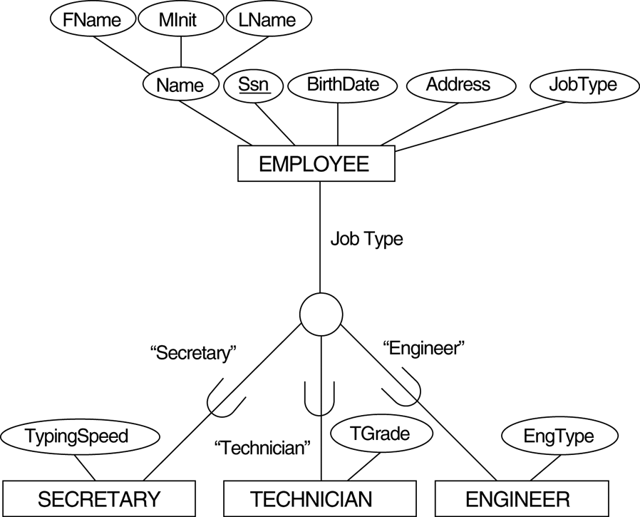

|  |
| --- |
| fig07_05 |

1. (**20 marks**). Study the following questions carefully and select the most appropriate option. Write your answer in the table provided below. Each question is worth two marks.

|  |  |  |  |  |  |  |  |  |  |
| --- | --- | --- | --- | --- | --- | --- | --- | --- | --- |
| 1 | 2 | 3 | 4 | 5 | 6 | 7 | 8 | 9 | 10 |
| C | C | B | C | A | D | E | C | E | A |

1. A given relation is known to be in third normal form. Select the statement which can be inferred from this:
2. All attributes contribute to the primary key
3. Each non-key attribute determines the primary key
4. Each non-key attribute is determined by the primary key
5. Every determinant is a candidate key
6. The relation is not in fourth normal form.
7. There are two relations X and Y. Relation X has arity 1 and cardinality 2, relation Y has arity 3 and cardinality 4. Indicate the result of the SQL statement SELECT COUNT(\*) FROM X,Y.
8. 4
9. 6
10. 8
11. Cannot be calculated from the information given
12. None of the above.
13. Which of the following is generally a benefit of normalisation?
14. Performance is improved
15. Insertion anomalies are avoided
16. Selection anomalies are avoided
17. Number of tables is reduced
18. None of the above.
19. A lack of normalisation can lead to which one of the following problems
20. Lost Updates
21. Deletion of data
22. Insertion problems
23. Deferred updates
24. Deadlock
25. To transform a relation from first normal form to second normal form we must remove which one of the following?
26. All partal-key dependencies
27. All inverse partial-key dependencies
28. All repeating groups
29. All transitive dependencies
30. None of the above
31. To transform a relation from second normal form to third normal form we must remove which one of the following?
32. All partal-key dependencies
33. All inverse partial-key dependencies
34. All repeating groups
35. All transitive dependencies
36. None of the above
37. Each of the following is an argument which might be used to support the use of relations which are not fully normalised. Select the **weakest** argument.
38. A fully normalised database may perform too slowly
39. Full normalisation may compromise existing applications/systems
40. A fully normalised database may have too many tables
41. Full normalisation may make some queries too complicated
42. A fully normalised database may result in tables which are too large
43. Consider the following functional dependencies

|  |  |  |  |  |  |  |
| --- | --- | --- | --- | --- | --- | --- |
| a,b | => | c,d |  | e,g,h | => | f,j |
| a,c | => | b,d |  | p,q | => | r,s |
| e,f,g | => | h,i |  | s | => | t |
| f,g | => | j |  | q | => | u |
| g,h | => | i |  |  |  |  |

Which of the following relational schemas might be the result of normalising R(s,q,t,u)?

1. The schema R1(s,q) R2(s,t) R3(q,u)
2. The schema R1(s,q) R2(q,t) R3(t,u)
3. The schema R1(s,q) R2(s,t) R3(q,u)
4. The schema R1(s,q,t) R2(s,q,u)
5. The schema R(s,q,t,u)
6. Consider the following functional dependencies

|  |  |  |  |  |  |  |
| --- | --- | --- | --- | --- | --- | --- |
| a,b | => | c,d |  | e,g,h | => | f,j |
| a,c | => | b,d |  | p,q | => | r,s |
| e,f,g | => | h,i |  | s | => | t |
| f,g | => | j |  | q | => | u |
| g,h | => | i |  |  |  |  |

Which of the following relational schemas might be the result of normalising R(a,b,c,d)?

1. The schema R1(a,b) R2(a,c) R3(a,d)
2. The schema R1(a,b) R2(b,c) R3(c,d)
3. The schema R1(a,b) R2(a,c) R3(b,d)
4. The schema R1(a,b,c) R2(a,b,d)
5. The schema R(a,b,c,d)
6. Consider the following functional dependencies

|  |  |  |  |  |  |  |
| --- | --- | --- | --- | --- | --- | --- |
| a,b | => | c,d |  | e,g,h | => | f,j |
| a,c | => | b,d |  | p,q | => | r,s |
| e,f,g | => | h,i |  | s | => | t |
| f,g | => | j |  | q | => | u |
| g,h | => | i |  |  |  |  |

Which of the following best describes the relation R(e,f,g,h,i,j)?

1. First Normal Form
2. Second Normal Form
3. Third Normal Form
4. Forth Normal Form
5. Boyce Codd Normal Form